AFTER RECORDING, RETURN TO:

Davis Wright Tremaine 1800 Bellevue Place 10500 N.E. 8th Street Bellevue, WA 98004-4300 Attn: Warren Koons

FIRST AMENDMENT TO DECLARATION AND COVENANTS, CONDITIONS, RESTRICTIONS AND EASEMENTS FOR MONTREUX

GLACIER RIDGE PARTNERSHIP (LIMITED PARTNERSHIP), a Washington
limited partnership (the "Declarant"), being the developer of the real property subject to the Declaration and Covenants, Conditions, Restrictions and Easements for Montreux (the "Declaration"), dated June 14, 1991, and recorded under King County Recording No. 9106210262 on June 21, 1991, and the declarant under the Declaration, hereby enters into and executes this First Amendment to the Declaration as of this 9th day of December, 1992.

The Declaration is hereby amended as follows:

RESTATED SECTION 5.2.4 (Minimum House size)

Section 5.2.4 of the Declaration, relating to minimum house size, is amended and restated to read in its entirety as follows:

5.2.4. Minimum House Size. All residences constituting part of a Living Unit shall have a minimum floor area of 2,600 square feet, exclusive of any garage area, unless otherwise approved by the ACC; provided, however, the minimum floor area for residences constituting part of a Living Unit within Division 2 shall be 2,200 square feet, exclusive of any garage area, unless otherwise approved by the ACC.

RESTATED SECTION 5.2.6 (Building Setbacks)

Section 5.2.6 of the Declaration, relating to building setbacks, is amended and restated to read in its entirety as follows:

    - Building Setbacks. The setback provisions in this Section apply to the Lots, subject to the maximum building ridge heights and special building setbacks for certain Lots as set forth in Exhibit C. As used herein, the term "Building Improvements" means Improvements other than vegetation and ACC approved landscaping, utilities, fences, yard lamps, hedges, driveways, gates, patios, tennis or basketball or sport courts, swimming pools or other recreational facilities not having a roof. The setback lines established below are lines that establish definite points beyond which no Building Improvements shall extend. Roof overhangs may extend a maximum of twelve (12) inches outside these setback lines, unless approved by the ACC. The ACC shall have the power to authorize variations to the building setbacks specified herein to allow for extenuating circumstances, as the ACC deems appropriate.

      - Sideyard. All Building Improvements shall have minimum sideyard setbacks of seven and one-half (7-1/2) feet from the sideyard lot line on either side and minimum distances between residences constituting part of a Living Unit of fifteen (15) feet; provided,, however, that for Lots in Division 2, the minimum sideyard setback for such Building Improvements shall be five (5) feet on either side and the minimum distance between residences constituting part of a Living Unit shall be ten (10) feet. In addition, no walls two (2) stories or higher may be located closer than ten (10) feet to a sideyard lot line; provided, however. that for Lots in Division 2, no walls of two (2) stories or higher may be located closer than seven and one-half (7-1/2) feet to a sideyard lot line.

5.2.6.2. Front. All Building Improvements shall have minimum frontyard setbacks of twenty (20) feet from the frontyard lot line in accordance with applicable laws. In addition, Lots (other than Lots in Division 2) with front-entry garages which face the street shall have minimum setbacks of forty (40) feet from the driveway edge of the curb to the garage doors. Building Improvements on corner Lots shall be setback a minimum of twenty
(20) feet from both streetside lot lines.

      - Driveway Width. Driveway widths at the curb shall not exceed twenty (20) feet.

2

      - Back. All Building Improvements shall have minimum backyard setbacks no less than twenty-five (25) feet from the rear lot line, although thirty (30) feet is preferable; provided, however. that for Lots in Division 2, all Building Improvements shall have minimum backyard setbacks of five (5) feet from the rear lot line; provided,, further. that Lots in Division 2 that back to a wildlife corridor, NGPE, greenbelt or public access roadway, may be subject to more restrictive setback requirements as shown on the Final Plat of Division 2.

5.2.6.5. General. Exceptions to the standards described in this Section 5.2.6 may be made by written approval of the ACC, in the ACC's discretion. All Improvements to be constructed on a Lot shall be built in conformance with applicable building setback requirements as set forth in any or all of the following: the building or zoning codes; Plat conditions, including subsequently recorded phases; a recorded document; or through the ACC's design review of any proposed Improvement, or in the general criteria adopted by the ACC. If the ACC grants any variance from minimum setbacks, the ACC may require the installation of fences, hedges, plantings or other visual barriers along the revised setback line or other mitigating measures. Plat conditions require specific ^{v} building setbacks from streams, NGPEs, wildlife corridors, utility easements and tops of major slopes.

RESTATED SECTION 5.2.8 (Building Heights)

Section 5.2.8 of the Declaration, relating to building heights, is amended and restated to read in its entirety as follows:
5.2.8 Building Heights. The maximum height of any residence shall be in conformity with all applicable building codes and regulations; provided, however, the maximum height of any residence in Division 1 shall be no higher than those established by the Declarant for any particular Division 1 Lot through recording of an Exhibit C to the Declaration (or revisions to Exhibit C). A set of approved building plans must be on the job site at all times. At the time of 100% framing, no further construction shall occur until the builder has submitted to the Declarant or the ACC a written verification by a licensed architect, engineer or surveyor that the ridge

heights of the construction meet the approved height restrictions herein.

NEW SECTION 9.6.1 (Special Assessments for Advances and Enforcement)

A new Section 9.6.1. relating to special assessments for advances and enforcement, is added to the Declaration to read in its entirety as follows:
9.6.1. Special Assessments for Advances and Enforcement. In addition to the general and special assessments authorized in Sections 9.3. 9.4. 9.5 and 9.6. the Board (without a vote of the Association membership) may, during the Development Period, levy from time to time a special assessment against any Lot(s) whose Owner fails within the Notice Period to (i) fully cure any violation or breach by such Owner or its contractors, subcontractors, employees or agents of any covenants contained in this Declaration, the Purchase and Sale Agreement with Declarant pertaining to such Lot(s), or any rules or , regulations established by the Association, or (ii) completely remove, clean up and repair any damage caused by (x) the construction-related activities of such Owner or its contractors, subcontractors, employees or agents or (y) any trash, garbage, dirt, or other debris, material or equipment deposited 'or placed on any street, Common Area, sidewalk, Lot or other portion of the Property (not owned by such Owner) by such Owner or its contractors, subcontractors, employees or agents. As used herein, the term "Notice Period" shall mean the forty-eight (48) hour period after the Association or Board gives written notice of such problem to such Owner or its on- site contractors, subcontractors, employees or agents; provided, the Association or Board may, in its discretion, designate a shorter or longer Notice Period in its notice; provided, further, that if in the Board's discretion, the circumstances are such as to make giving written notice impracticable or problematical, such notice may be orally given to such Owner or its on-site contractors, subcontractors, employees or agents, and the Notice Period shall, in such case, commence on the giving of such oral notice. The amount of such special assessment shall be in such amount as is advanced by the Association to cure the problem or as may reasonably be estimated by

the Association as an amount necessary to cure such problem, plus the Association's costs and reasonable attorneys⁷ fees in connection therewith and in the enforcement and/or foreclosure of such special assessment or the lien created thereby. The Association or Board may adjust the amount of such special assessment by subsequent notice to such Owner, as may be appropriate based on amounts advanced or that may be advanced by the Association to cure the problem and its applicable attorneys' fees and related costs. Such special assessment shall commence and be payable by such Owner after expiration of the Notice Period and shall constitute from and after such date a lien in the full amount thereof against such Owner's Lot or Lots. Notwithstanding Section 9.7, such special assessment shall not be a lien against any Lots not owned by such Owner, unless and until it is separately established as a special assessment pursuant to Section 9.6.

RESTATED SECTION 9.7 (Amount of Assessment)

Section 9.7 of the Declaration, relating to the amount of assessment, is amended and restated to read in its entirety as follows:

9.7 Amount of Assessment. The amount of the" general or special assessment attributable to each Lot shall be equal to the total amount of such assessment divided by the total number of Lots for which final plat approval has been recorded; provided, however, the amount of the assessment attributable to a Lot with respect to a special assessment made pursuant to Section 9.6.1 shall be as provided in Section 9.6.1.

- Except as specifically modified herein, all terms, provisions, and conditions of the Declaration shall remain in full force and effect.
Declarant: GLACIER RIDGE PARTNERSHIP (LIMITED
PARTNERSHIP), a Washington limited partnership

By WARJONE INVESTMENTS, INC., Its
General Partner
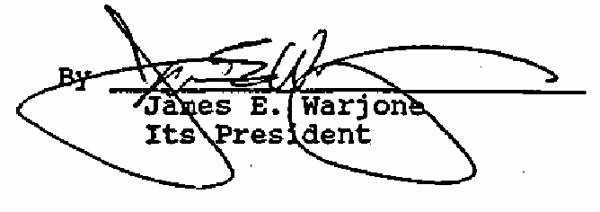

STATE OF WASHINGTON )
) ss.

COUNTY OF KING )

On this 9th day of December, 1992, before me, a Notary
Public in and for the State of Washington, personally appeared JAMES E. WARJONE, personally known to me (or proved to me on the basis of satisfactory evidence) to be the person who executed this instrument, on oath stated that he was authorized to execute the instrument, and acknowledged it as the President of WARJONE INVESTMENTS, INC., to be the free and voluntary act and deed of said corporation for the uses and purposes therein mentioned; and on oath stated that he was duly elected, qualified, and acting as said officer of the corporation; that said corporation is the general partner of GLACIER RIDGE PARTNERSHIP (LIMITED PARTNERSHIP), a Washington limited partnership; that said corporation was authorized to execute the said instrument on behalf of said partnership; and that said instrument was the free and voluntary act and deed of said partnership for the uses and purposes therein mentioned.
IN WITNESS WHEREOF, I have hereunto set my hand and official seal the day and year first above written.
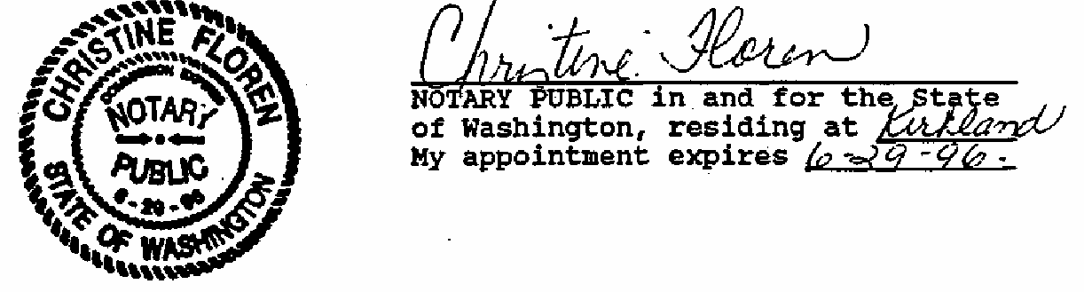

AFTER RECORDING, RETURN TO:
Davis Wright Tremaine 1800 Bellevue Place 10500 N.E. 8th Street Bellevue, WA 98004-4300 Attn: Warren Koons

SECOND AMENDMENT TO DECLARATION AND COVENANTS, CONDITIONS, RESTRICTIONS AND EASEMENTS FOR MONTREUX

GLACIER RIDGE PARTNERSHIP (LIMITED PARTNERSHIP), a Washington
limited partnership (the "Declarant"), being the developer of the real property subject to the Declaration and Covenants, Conditions, Restrictions and Easements for Montreux, dated June 14, 1991, and recorded under King County Recording No. 9106210262 on June 21, 1991, as amended by the ' First Amendment thereto dated December 9, 1992, and recorded under King County Recording No. 9212112069 (collectively, the "Declaration"), and being the declarant under the Declaration, hereby enters , into and executes this Second Amendment to the Declaration as of this 29th day of January, 1993.

The Declaration is hereby amended as follows:
- RESTATED SUBSECTION 5.2.6.1 (Sideyard Setbacks)

Subsection 5.2.6.1 of the Declaration, relating to sideyard setbacks, is amended and restated to read in its entirety as follows:
5.2.6.1 Sideyard. All Building Improvements shall have minimum sideyard setbacks of seven and one-half (7-1/2) feet from the sideyard lot line on either side and minimum distances between residences constituting part of a Living Unit of fifteen (15) feet; provided, however. that for Lots in Division 2, the minimum sideyard setback for such Building Improvements shall be five (5) feet from the sideyard lot line on either side and the minimum distance between residences constituting part of a Living Unit shall be ten (10) feet. In addition, no walls two (2) stories or higher may be located closer than ten (10) feet to a sideyard lot line; provided, however, that for Lots in Division 2, walls of two (2) stories or higher may be located as close as, but no closer than, five
(5) feet to a sideyard lot line.

- Except as specifically modified herein, all terms, provisions, and conditions of the Declaration shall remain in full force and effect.
Declarant: GLACIER RIDGE PARTNERSHIP (LIMITED
PARTNERSHIP), a Washington limited partnership

By WARJONE INVESTMENTS, INC., Its
General Partner
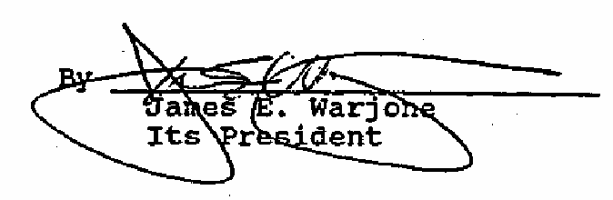

STATE OF WASHINGTON )
) ss.

COUNTY OF KING )

On this 29th day of January, 1993, before me, a Notary Public in and for the State of Washington, personally appeared JAMES E. WARJONE, personally known to me (or proved to me on the basis of satisfactory evidence) to be the person who executed this instrument, on oath stated that he was authorized to execute the instrument, and acknowledged it as the President of WARJONE INVESTMENTS, INC., to be the free and voluntary act and deed of said corporation for the uses and purposes therein mentioned; and on oath stated that he was duly elected, qualified, and acting as said officer of the corporation; that said corporation is the general partner of GLACIER RIDGE PARTNERSHIP (LIMITED PARTNERSHIP), a
Washington limited partnership; that said corporation was authorized to execute the said instrument on behalf of said partnership; and that said instrument was the free and voluntary act and deed of said partnership for the uses and purposes therein mentioned.
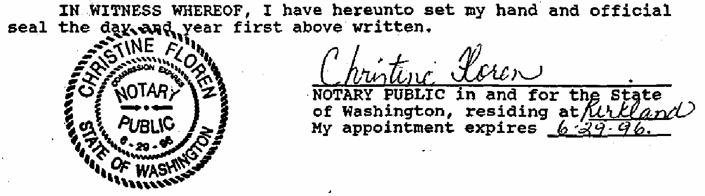


AFTER RECORDING, RETURN TO:

Davis Wright Tremaine 1800 Bellevue Place 10500 N.E. 8th Street Bellevue, WA 98004-4300 Attn: Warren Koons

THIRD AMENDMENT TO DECLARATION AND COVENANTS, CONDITIONS, RESTRICTIONS AND EASEMENTS FOR MONTREUX

GLACIER RIDGE PARTNERSHIP (LIMITED PARTNERSHIP), a Washington
limited partnership (the "Declarant"), being the developer of the real property subject to the Declaration and Covenants, Conditions, Restrictions and Easements for Montreux, dated June 14, 1991, and recorded under King County Recording No. 9106210262 on June 21, 1991, as amended by the First Amendment thereto dated December 9, 1992, and recorded under King County Recording No. 9212112069, and by the Second Amendment thereto dated January 29, 1993, and recorded under King County Recording No. 9302021632 (collectively, the "Declaration"), and being the declarant under the Declaration, hereby enters into and executes this Second Amendment to the Declaration as of this 19th day of February, 1993.

The Declaration is hereby amended as follows:

- RESTATED SECTION 5.2.2 (Building Plans)

Section 5.2.2 of the Declaration, relating to building plans, is amended and restated to read in its entirety as follows:
5.2.2 Building Plans. No Living Unit or other Improvement shall be commenced, erected, or maintained upon a Lot or any other portion of the Property, nor shall any exterior addition to or change or alteration therein or landscaping be made, until after the details and written plans and specifications (and any changes or modifications thereto) showing the nature, kind, shape, height, materials, colors, and location of the same, a construction erosion control plan, a landscaping plan, and any other submittals described in the Architectural Design Guidelines, shall have been submitted to and approved in writing by the Architectural Control Committee as provided in Section 8.6. to ensure the harmony of

external design and location in relation to surrounding structures, vegetation, and topography. No construction activity of any kind shall be commenced on any Lot without the written approval of the Architectural Control Committee. If the written approval of the Architectural Control Committee is not obtained in advance for all such details, plans, specifications and submittals, and any change or modification thereto, or if any Improvement or portion thereof is constructed or installed except in accordance with the details, plans and specifications approved by the Architectural Control Committee, or if any construction activity is commenced without the prior approval of the Architectural Control Committee, then the Lot or Lots upon which such Living Unit or other Improvement is constructed or installed or is being constructed or installed shall be subject to the imposition of the Special Assessment and Lien in accordance with Section 9.6.1 of this Declaration, and, in addition thereto and to any other right or remedy it may have, the Association and/or Declarant shall have the right to obtain a temporary restraining order and/or injunction to stop such work and remove any Improvement or portion thereof constructed or installed in violation of this Section.

- RESTATED SECTION 5.2.5 (Roofs)

Section 5.2.5 of the Declaration, relating to roofs, is amended and restated to read in its entirety as follows:
    - Roofs; Chimneys; siding; and Other Design/Quality Requirements. Shake roofs are acceptable, but shingle or substitute roofing materials may be approved by the Architectural Control Committee. Composition and Spanish-tile roofs are prohibited. The Architectural Control Committee may require that in highly visible locations chimneys be finished with masonry or stucco material, and in such locations chimneys finished with wood materials will be discouraged. If wood siding is used in construction, such siding should be of a clear grade on the street sides. The Architectural Control Committee will encourage residence designs that promote diversity, and similar front elevations will be discouraged for adjacent Lots. All residences and

other Improvements (including landscaping) should be finished to an appropriate standard of quality commensurate with the neighborhood.

ADDITION TO SECTION 8.6.1 (ACC Established; Required Approvals)

Section 8.6.1 of the Declaration, relating to the Architectural Control Committee, established and required approvals, is amended by adding the following sentence to the end of such Section:
Each Owner also must submit any changes or amendments to any details, plans or specifications for proposed residences and other Improvements to the Architectural Control Committee for approval, and each Owner must obtain the written approval of the ACC for any such changes or amendments before commencement of construction of any residence or other Improvements affected by such changes or amendments, and construction must strictly conform to the changes and amendments approved by the ACC.

- Except as specifically modified herein, all terms> provisions, and conditions of the Declaration shall remain in full force and effect.
Declarant: GLACIER RIDGE PARTNERSHIP (LIMITED
PARTNERSHIP), a Washington limited partnership
By WARJONE INVESTMENTS, INC., Its
General Partner
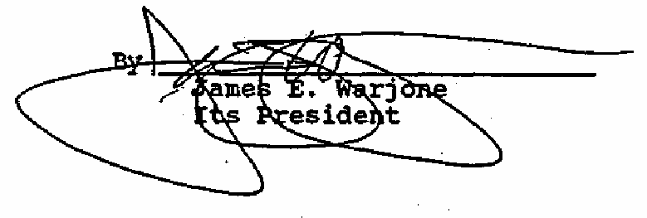

STATE OF WASHINGTON )
) ss.

COUNTY OF KING )

On this 19th day of February, 1993, before me, a Notary Public in and for the State of Washington, personally appeared JAMES E. WARJONE, personally known to me (or proved to me on the basis of satisfactory evidence) to be the person who executed

3

this instrument, on oath stated that he was authorized to execute the instrument, and acknowledged it as the President of WARJONE INVESTMENTS, INC., to be the free and voluntary act and deed of said corporation for the uses and purposes therein mentioned; and en oath stated that he was duly elected, qualified, and acting as said officer of the corporation; that said corporation is the general partner of GLACIER RIDGE PARTNERSHIP (LIMITED PARTNERSHIP), a Washington limited partnership; that said corporation was authorized to execute the said instrument on behalf of said partnership; and that said instrument was the free and voluntary act and deed of said partnership for the uses and purposes therein mentioned.
IN WITNESS WHEREOF, I have hereunto set my hand and official seal the day and year first above written.

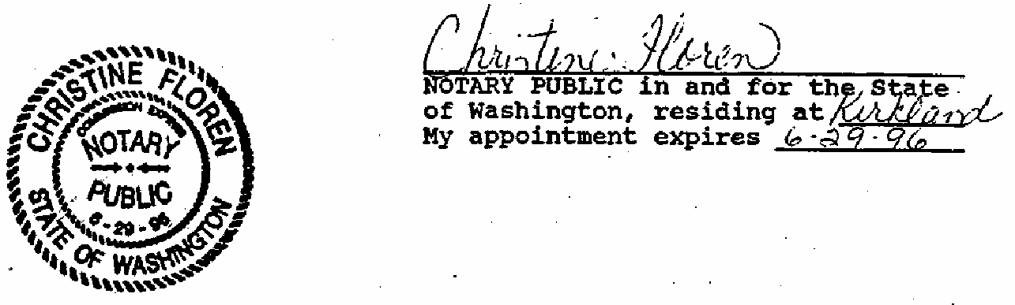

AFTER RECORDING, RETURN TO:

Davis Wright Tremain
Attn: Warren E. Koons ORIGINAL RECORDED ON DECEMBER 17, 1993. 10500 N.E 8th Street UNDER KING COUNTY AUDITOR'S FILE NUMBER Bellevue, WA 98004-4300 9312172692.

FOURTH AMENDMENT TO DECLARATION AND COVENANTS, CONDITIONS, RESTRICTIONS AND EASEMENTS FOR MONTREUX

GLACIER RIDGE PARTNERSHIP (LIMITED PARTNERSHIP), a Washington
limited partnership (the "Declarant"), being the developer of the real property subject to the Declaration and Covenants, Conditions, Restrictions and Easements for Montreux, dated June 14, 1991, and recorded under King County Recording No. 9106210262, as amended by the First Amendment thereto dated December 9, 1992, and recorded under King County Recording No. 9212112069, by the Second Amendment thereto, dated January 29, 1993, and recorded under King County Recording No. 9302021632, and by the Third Amendment thereto dated February 19, 1993, and recorded under King County Recording No. 9302241791 (collectively, the "Declaration"), and being the declarant under the Declaration, hereby enters into and executes this Fourth Amendment to the Declaration as of this 14th day of December, 1993.

Recitals

Since the recordation of the original Plat of Montreux, recorded February 26, 1991, in Volume 155, Pages 69-87 of Plats, under King County Recording No. 9102260180, the following Plats,' re-platting portions of Montreux, have been recorded: Plat for Division 2 of Montreux, recorded February 1, 1993, in Volume 163, Pages 56-63 of Plats, under King County Recording No. 9302011215; Plat for Division
3 of Montreux, recorded September 29, 1993, in Volume 166, Pages 1-6 of Plats, under King County Recording No. 9309291191; and Plat for Division 4 of Montreux, recorded December 15, 1993, in Volume 167, Pages 8-11 of Plats, under King County Recording No. 9312152112.

The Declaration is hereby amended as follows:

- ADDITION TO SECTION 5.2.1 (Contractor and Architect)

Section 5.2.1 of the Declaration, relating to Contractor and Architect, is amended by adding the following paragraph to the end of such Section:

Prior to the commencement of any work or construction of any Improvement or Living Unit on a Lot, the general contractor or builder (the "Contractor") for such work, if different from the Owner, shall enter into a .Builder/Contractor's Agreement for Montreux in favor of Declarant and the Association, in such form as Declarant or the Association may require, pursuant to which the Contractor acknowledges receipt of and agrees to be bound by the terms and provisions of this Declaration relating to any work or construction on a Lot and to be personally liable for failure to comply with such provisions. In connection with such Builder/Contractor's Agreement, the Owner of such Lot shall agree in writing for the benefit of the Declarant and Association that such agreement does not diminish or relieve such Owner's obligations hereunder and that the Declarant, Association and ACC may rely upon the submittals by such Contractor as if the same were presented by the Owner for approval.
- ADDITION TO SECTION 5.2.2 (Building Plans)

Section 5.2.2 of the Declaration, relating to Building Plans, is amended by adding the following paragraph to the end of such Section:
The ACC may, in its sole discretion, on a case by case basis, require that prior to the pouring of concrete for a foundation on a Lot the Owner or Contractor provide the ACC with a licensed surveyor's survey of the applicable area of the. Lot verifying that said improvements will be located in the location previously approved by the ACC.

- RESTATED SUBSECTION 5.2.6 (Building Setbacks)

Section 5.2.6 of the Declaration, relating to building setbacks, is amended and restated to read in its entirety as follows:

    - Building Setbacks. The setback provisions in this Section apply to the Lots, subject to (i) the maximum building ridge heights and special building setbacks for certain Lots as set forth in Exhibit c and (ii) a maximum building ridge height of 18 feet to top of ridge, measured from top of curb on street at the centerline of the subject Lot along the street, for Lots 2, 3, 4 and 5 of Division 3. As used herein, the term "Building Improvements" means Improvements other than vegetation, and ACC approved landscaping, utilities, fences, yard lamps, hedges, driveways, gates, patios, tennis or basketball or sport courts, swimming pools or other recreational facilities not having a roof. The setback lines established below are lines that establish definite points beyond which no Building Improvements shall extend. Roof overhangs may extend a maximum of twelve (12) inches outside these setback lines, unless approved by the ACC; provided, however, for Lots 81-86 and 99-104 in Division 2, roof overhangs and fireplaces may extend eighteen (18) inches outside these setback lines unless a greater overhang is approved by the ACC. The ACC shall have the power to authorize variations to the building setbacks specified herein to allow for extenuating circumstances, as the ACC deems appropriate.

      - Sideyard. All Building Improvements shall have minimum sideyard setbacks of seven and one-half (7- 1/2) feet from the sideyard lot line on either side and minimum distances between residences constituting part of a Living Unit of fifteen (15) feet; provided, however. that for Lots in Divisions 2, 3 and 4, the minimum sideyard setback for such Building Improvements shall be five (5) feet from the sideyard lot line on either side and the minimum distance between residences constituting part of a Living Unit shall be ten (10) feet. In addition, no walls two (2) stories or higher may be located closer than ten
(10) feet to a sideyard lot line; provided, however. that for Lots in Divisions 2, 3 and 4, walls of two (2) stories or higher may be located as close as, but no - closer than, five (5) feet to a sideyard lot line.

      - Front. All Building Improvements shall have minimum frontyard setbacks of twenty (20) feet from the frontyard lot line in" accordance with applicable laws. In addition, Lots with front-entry garages which face the street shall have minimum setbacks of forty (40) feet from the driveway edge of the curb to the garage doors; provided, however, that for Lots in Divisions 2,

3

3 and 4, such front-entry garages shall have minimum setbacks of twenty (20) feet from the front yard lot line to the garage doors. Building Improvements on corner Lots shall be setback a minimum of twenty (20) feet from both streetside lot lines.
      - Driveway Width. Driveway widths at the curb shall not exceed twenty (20) feet.

      - Back. All Building Improvements shall have minimum backyard setbacks no less than twenty-five (25) feet from the rear lot line, although thirty (30) feet is preferable; provided, however, that for Lots in Divisions 2 and 3, all Building Improvements shall have minimum backyard setbacks of five (5) feet from the rear lot line; provided, further. that Lots in Divisions 2 and 3 that back to a wildlife corridor, NGPE, greenbelt or public access roadway, may be subject to more restrictive setback requirements as shown on the Final Plats of Divisions 2 and 3, respectively.

      - General. Exceptions to the standards described in this Section 5.2.6 may be made by written approval of the ACC, in the ACC's discretion. All Improvements to be constructed on a Lot shall be built in conformance with applicable building setback requirements as set forth in any or all of the following: the building or zoning codes (except to the extent the requirements of this Declaration are more stringent than those required by such codes); Plat conditions, including subsequently recorded phases; a recorded document; or through the ACC's design review of any proposed Improvement, or in the general criteria adopted by the ACC. If the ACC grants any variance from minimum setbacks, the ACC may require the installation of fences, hedges, plantings or other Visual barriers along the revised setback line or other mitigating measures. Plat conditions require specific building setbacks from streams, NGPEs, wildlife corridors, utility easements and tops of major slopes.

- NEW SUBSECTION 5.2.6.6 (Variances)
A new Section 5.2.6.6, relating to variances by the ACC, is added to the Declaration to read in its entirety as follows:
      - Variances; Procedure for Variances. The ACC may, in its discretion, grant variances to the setback requirements and other construction requirements set forth in this Declaration. However, the Declarant

recognizes that the ACC's granting of a variance with respect to a particular Lot may impact the Owners of adjacent Lots, and therefore believes that it is in the best interest of the Montreux development and the Owners to establish a procedure whereby any Owner of a Lot adjacent to a Lot for which a variance has been requested of the ACC and which would be materially affected by the granting of such variance will be given notice and an opportunity to be heard with respect to the proposed variance and any proposed mitigation measures. The ACC shall establish and make available to all Owners written guidelines, acceptable to the Board, setting forth the procedures and manner in which such notice to and opportunity to be heard by such adjacent Lot Owners shall be governed. With the concurrence of the Board, the ACC's written guidelines may be modified from time to time and copies of such modified guidelines shall be provided to the Owners. Notwithstanding the fact that one or more Owners may object to the granting of a variance by the ACC or its required mitigation measures, the ACC shall have the right and authority to grant any variance and require any such mitigation in connection therewith which the ACC determines in good faith is appropriate and reasonable, so long as the ACC has determined, in its sole discretion, that any material adverse affect such variance has on an adjacent Lot can be substantially reduced by such mitigation measures.

- RESTATED SECTION 5.2.8 (Building Heights)

Section 5.2.8 of the Declaration, relating to building heights, is amended and restated to read in its entirety as follows:

5.2.8 Building Heights. The maximum height of any residence shall be in conformity with all applicable building codes and regulations; provided, however, the maximum height of any residence on certain Lots in Division
1 shall be no higher than those established by Declarant for such Lots as set forth on Exhibit C to the Declaration; provided, further, the maximum height of any residence on Lots 2, 3, 4 and 5 of Division 3 shall be eighteen (18) feet measured from the top of the curb on the street at the centerline of such Lot along the street. A set of approved building plans must be on the job site at all times. At the time of 100% framing, no further construction shall occur until the builder has submitted to the Declarant or the ACC a written verification by a licensed architect, engineer or
5

surveyor that the ridge heights of the construction meet the approved height restrictions herein.

- ADDITION TO SECTION 6.2.7 (Maintenance of Lakes)

Section 6.2.7 of the Declaration, relating to .the Maintenance of Lakes, is amended by adding the following paragraphs to the end of such Section:

The Association or its appointees shall clean the Lakes of all debris, wild grasses, tree shoots, leaves and other deleterious or harmful materials of whatever kind twice each calendar year, once in March and once in October (or at such other times as the Association determines is appropriate). Siltation and mud buildups in the Lakes shall be removed by a qualified professional selected by the Association at such times as the Association determines is appropriate or the City of Issaquah so requires. In addition to the foregoing, the Association's maintenance of the Lakes shall include maintaining the elevation of the water level in the Lakes in accordance with the approved engineering drawings for -the Plat of Division 2 of Montreux or as the Association determines is necessary.

The Association shall appoint a committee of three Owners, two of whom must live on Lots that abut a Lake, and such committee shall have the responsibility for monitoring and controlling the required water level for each of the Lakes. Said committee shall report to and serve at the pleasure of the Association, and the Association shall have the power and authority to remove, replace and appoint members of said committee as it deems appropriate. All costs arising in connection with the maintenance of the Lakes and monitoring and control of the water level in the Lakes shall be Common Expenses, subject, however, to appropriate allocation among Owners as the Association may determine, as set forth above.
The portion of each Lot that is within the easement • area of the above-described ten (10) foot wide easement around each Lake shall be landscaped and maintained by the Owner of said Lot; provided, however, that such landscaping shall be subject to the ACC's prior approval, and no fences, improvements, obstructions or structures of any nature shall be installed by an Owner on said easement area. Any damage to the easement area caused by the Association's maintenance of the Lakes or monitoring and control of the water level in the Lakes, shall be

repaired by the Association and included in the Common Expenses.

- ADDITION OF NEW SECTION 6.2.8 (WATER FEATURES)

A new Section 6.2.8. relating to .Water Features, is added to the Declaration to read in its entirety as follows:

6.2.8 Water Features. Although neither the Declarant nor the Association shall have any obligation to install any fountain, lights, rockery or other water feature not necessary to the drainage of a Lake ("Water Features") in any of the Lakes, the Association has agreed to permit a builder to install, at such builder's option and sole cost and expense,' a Water Feature consisting of water fountain and lights in the Lake located on Tract E of Division 2, and the Association may in the future agree to allow Water Features to be installed in one or more of the other Lakes; provided, however, any Water Feature installed in a Lake shall be subject to the prior written approval of the ACC with respect to design, siting and other specifications. The Association shall provide the maintenance and repair for all approved Water Features and shall carry liability insurance in such forms and amounts as it deems appropriate for such Water Features; however, the cost of the maintenance, repair, and liability insurance for a Water Feature shall be borne solely by the Owners of the Lots which directly abut the Lake containing such Water Feature in equal pro rata amounts, and such abutting Lot Owners shall promptly reimburse the Association for costs when billed. Thus, for example, the Owners of Lots 71-73, 75 and 77-80 in Division 2 shall, if any Water Features are built on the Lake on Tract E, each be responsible to pay one- eighth of all such Water Feature-related expenses.
- ADDITION TO SECTION 1.4.1 (Enforcement)

Section 14.1 of the Declaration, relating to Enforcement, is amended by adding the following paragraphs to the end of such Section:
    - Resolution of Certain Disputes. It is Declarant's intent to establish procedures to facilitate the informal and efficient resolution of certain disputes arising under Section 5.2 of this Declaration, without waiving any rights or remedies that may be available to Declarant, the ACC, the Association or any Owner. In

furtherance of this objective, Declarant, the Association, ACC and each Owner shall follow the procedures set forth below as a condition precedent to the initiation of any lawsuit or court proceeding (except as set forth in Section 14.1.4 below) if and when a dispute or controversy arises as to whether an Owner (or its Contractor) has failed to comply with the provisions of Section 5.2 of this Declaration (a "Dispute").
    - Notice of Dispute; Resolution Meeting. The complaining party (be it an Owner, the "Declarant, the ACC or the Association) shall prepare a written description of the alleged Dispute and shall deliver a copy of it to the Owner(s) of the Lot(s) in question (and its Contractor, if applicable), with a copy to the Association, Declarant and ACC if the complaining party is an Owner.
The notice shall set forth the nature of the Dispute and a proposed solution to the Dispute, including a specific time period within which the parties must act. The Owner receiving the notice of Dispute shall respond to the complaining party in writing within five (5) days with a written explanation, including a response to the solution proposed by the complaining party. Within five (5) days of receipt of this response, the parties shall meet without presence of legal counsel and discuss alternatives for resolving the Dispute. The complaining party shall be responsible for scheduling the time and location of the resolution meeting, which shall be during regular business hours in Issaquah, Washington.
    - Mediation. If the parties, for whatever reason, are unable to reach agreement to resolve the Dispute through the procedure set forth herein then each party to the Dispute shall participate in a mediation of the Dispute in accordance with this Section 14.1.3. A mediation shall be held within ten (10) days of an unsuccessful resolution meeting. The mediation shall be held at the Seattle office of Judicial Arbitration & Mediation Services, Inc. or such other mediation service as may be designated by the Association (“Mediation Service”). The complaining party shall contact the Mediation Service to schedule the mediation, which shall be during regular business hours. The parties to the Dispute shall agree on a mediator from the Mediation Service's panel to serve as the mediator; if they are unable to agree, then the
^Mediation Service shall be asked to name a qualified mediator to serve as mediator for the Dispute. The cost of the Mediation Service and mediator shall be paid in equal shares by the parties involved in the Dispute. The mediation decision shall be non-binding.

    - Other Remedies. Neither anything contained in Sections 14.1.1-14.1.3 above nor the results of such mediation shall (a) limit or restrict an Owner, the Declarant, the ACC or the Association from going to court to pursue any and all remedies available to such parties at law or in equity, after first pursuing resolution of a Dispute in the manner as set forth above, nor (b) limit, delay or restrict the right of an Owner, Declarant, the ACC or the Association to seek injunctive or other equitable court relief without the necessity of pursuing the procedures set forth in Sections 14.1.1-14.1.3 when such party reasonably believes such relief is necessary due to emergency circumstances or that material irreparable harm may result if delay occurs in seeking such relief, nor (c) limit, delay or restrict the Association's right to impose the Special Assessment and Lien or take the other actions authorized under Section 9.6.1, nor (d) require parties to follow such procedures with respect to a Dispute which exists prior to the date of the Fourth Amendment to the Declaration.

- Except as specifically modified herein, all terms, provisions, and conditions of the Declaration shall remain unmodified and in full force and effect.

Executed as of the date first above written.

DECLARANT: GLACIER RIDGE PARTNERSHIP (LIMITED PARTNERSHIP), a
Washington limited partnership
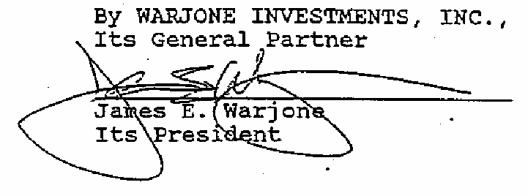
STATE OF WASHINGTON )
) ss.
COUNTY OF KING )
On this 17th day of December, 1993, before me, a Notary Public in and for the State of Washington, personally appeared JAMES E. WARJONE, personally known to me (or proved to me on the basis of satisfactory evidence) to be the person who executed this instrument, on oath stated that he was authorized to execute the instrument, and. acknowledged it as the President of

WARJONE INVESTMENTS, INC. to be the free and voluntary act and deed of said corporation for the uses and purposes therein mentioned; and on oath stated that he was duly elected, qualified, and acting as said officer of the corporation; that said corporation is the general partner of GLACIER RIDGE PARTNERSHIP (LIMITED PARTNERSHIP), a
Washington limited partnership; that said corporation was authorized to execute the said instrument on behalf of said partnership; and that said instrument was the free and voluntary act and deed of said partnership for the uses and purposes therein mentioned.

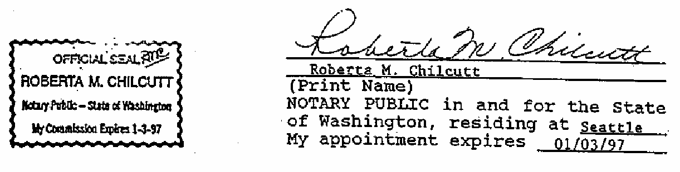
IN WITNESS WHEREOF, I have hereunto set my hand and official seal the day and year first above written.

AFTER RECORDING, RETURN TO:

Davis Wright Tremaine Attn: Warren E. Koons
1800 Bellevue Place [Recorded on April 8, 1994, 10500 N.E. 8th Street Under King County Recording Bellevue, WA 98004-4300 No. 9404081834]

FIFTH AMENDMENT TO DECLARATION AND COVENANTS, CONDITIONS, RESTRICTIONS AND EASEMENTS FOR MONTREUX

GLACIER RIDGE PARTNERSHIP (LIMITED PARTNERSHIP), a Washington
limited partnership (the "Declarant"), being the developer of the real property subject to the Declaration and Covenants, Conditions, Restrictions and Easements for Montreux, dated June 14, 1991, and recorded under King County Recording No. 9106210262, as amended by the First Amendment thereto dated December 9, 1992, and recorded under King County Recording No. 9212112069, by the Second Amendment thereto, dated January 29, 1993, and recorded under King County Recording No. 9302021632, by the Third Amendment thereto dated February 19, 1993, and recorded under King County Recording No. 9302241791, and by Fourth Amendment thereto dated December 14, 1993, and recorded under King County Recording No. 9312172692 (collectively, the "Declaration"), and being the declarant under the Declaration, hereby enters into and executes this Fifth Amendment to the Declaration as of this 7th day of April, 1994.

Recitals

Since the recordation of the original Plat of Montreux, recorded February 26, 1991, in Volume 155, Pages 69-87 of Plats, under King County Recording No. 9102260180, the following Plats, re-platting portions of Montreux, have been recorded: Plat for Division 2 of Montreux, recorded February 1, 1993, in Volume 163, Pages 56-63 of Plats, under King County Recording No. 9302011215; Plat for Division 3 of Montreux, recorded September 29, 1993, in Volume 166, Pages 1-6 of Plats, under King County Recording No. 9309291191; and Plat for Division
4 of Montreux, recorded December 15, 1993, in Volume 167, Pages 8-11 of Plats, under King County Recording No. 9312152112.

The Declaration is hereby amended as follows:

- RESTATED SUBSECTION 5.2.6.3 (Driveway Width)
Subsection 5.2.6.3 of the Declaration, relating to Driveway Width, is amended and restated to read in its entirety as follows:
5.2.6.3 Driveway Width. For Lots in Division 1, driveway widths at the curb shall not exceed twenty (20) feet. For Lots in Divisions 2, 3 and 4, driveway widths at the curb shall not exceed twenty-seven (27) feet.
- Except as specifically modified herein, all terms,. provisions, and conditions of the Declaration shall remain unmodified and in full force and effect.

Executed as of the date first above written.

DECLARANT: GLACIER RIDGE PARTNERSHIP (LIMITED PARTNERSHIP), a
Washington limited partnership
By WARJONE INVESTMENTS, INC., Its
General Partner
/s/ James E. Warjone
Its President

STATE OF WASHINGTON )
) ss.

COUNTY OF KING )
On this day of , 1994, before me, a Notary Public in and for the State of Washington, personally appeared JAMES E. WARJONE, 'personally known to me (or proved to me on the basis of satisfactory evidence) to be the person who executed this instrument, on oath stated that he was authorized to execute the instrument, and acknowledged it as the President of WARJONE INVESTMENTS, INC. to be the free and voluntary act and deed of said corporation for the uses and purposes therein mentioned; and on oath stated that he was duly elected, qualified, and acting as said officer of the corporation; that said corporation is the

general partner of GLACIER RIDGE PARTNERSHIP (LIMITED PARTNERSHIP) , a
Washington limited partnership; that said corporation was authorized to execute the said instrument on behalf of said partnership; and that said instrument was the free and voluntary act and deed of said partnership for the uses and purposes therein mentioned.

IN WITNESS WHEREOF, I have hereunto set my hand and official seal the day and year first above written.

(Print Name)

NOTARY PUBLIC in and for the State of Washington, residing at My appointment expires

AFTER RECORDING, RETURN TO: 9408091254
Davis Wright Tremaine Attn: Warren E. Koons 1800 Bellevue Place 10500 N.E. 8th Street Bellevue, WA 98004-4300

SIXTH AMENDMENT TO DECLARATION AND COVENANTS, CONDITIONS, RESTRICTIONS AND EASEMENTS FOR MONTREUX

GLACIER RIDGE PARTNERSHIP (LIMITED PARTNERSHIP), a Washington
limited partnership (the "Declarant"), being the developer of the real property subject to the Declaration and Covenants, Conditions, Restrictions and Easements for Montreux, dated June 14, 1991, and recorded under King County Recording No. 9106210262, as amended by the First Amendment thereto dated December 9, 1992, and recorded under King County Recording No. 9212112069, by the Second Amendment thereto, dated January 29, 1993, and recorded under King County Recording No. 9302021632, by the Third Amendment thereto dated February 19, 1993, and recorded under King County Recording No. 9302241791, by the Fourth Amendment thereto dated December 14, 1993, and recorded under King County Recording No. 9312172692, and by the Fifth Amendment thereto dated April 7, 1994, and recorded under King County Recording No. 9404081834 (collectively, the "Declaration"), and being the declarant under the Declaration, hereby enters into and executes this Sixth Amendment to the Declaration as of this 8th day of July, 1994.

The Declaration is hereby amended as follows:
- ADDITION TO SECTION 6.2.8 (Water Features)

Section 6.2.8 of the Declaration, relating to Water Features, is amended by adding the following sentence to the end of such Section:

The cost of any electrical power necessary for the operation of a Water Feature shall, as with the cost of the maintenance, repair and liability insurance for a Water Feature, be borne solely by the Owners of the Lots which directly abut the Lake containing such Water Feature in equal pro rata amounts, and such abutting Lot Owners shall reimburse the Association for such power

costs through a surcharge on the general assessment for such Lots.

ADDITION OF NEW SECTION 6.11 (MAILBOX CLUSTERS)

A new Section 6.11. relating to Mailbox Clusters, is added to the Declaration to read in its entirety as follows:
6.11 Mailbox Clusters. The cost of supplying electrical power to any mailbox cluster, whether the cluster is supplied electrical power for lighting by connection to the power line serving a Lot or whether it is separately metered, shall be borne by the Owners of all Lots through inclusion in the general assessment for all Lots. The power costs for mailbox clusters that are not separately metered shall be based on an estimate derived from the average power cost for metered mailbox clusters. Any Lot Owner who supplies electrical power to a mailbox cluster shall be reimbursed for the estimated cost thereof through a credit against the general assessment applicable to such Owner's Lot.

- Except as specifically modified herein, all terms, provisions, and conditions of the Declaration shall remain unmodified and in full force and effect.
Executed as of the date first above written.

DECLARANT: GLACIER RIDGE PARTNERSHIP (LIMITED PARTNERSHIP), a
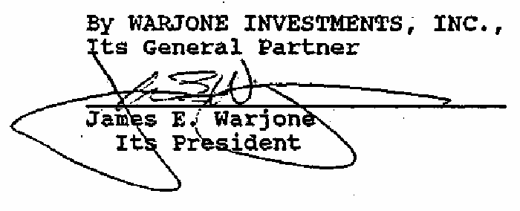
Washington limited partnership

STATE OF WASHINGTON )
) ss.

COUNTY OF KING )
On this 5th day of August 1994, before me, a Notary Public in and for the State of Washington, personally appeared JAMES E. WARJONE, personally known to me (or proved to me on the basis of. satisfactory evidence) to be the person who executed this

instrument, on oath stated that he was authorized to execute the instrument, and acknowledged it as the President of WARJONE INVESTMENTS, INC. to be the free and voluntary act and deed of said corporation for the uses and purposes therein mentioned; and on oath stated that he was duly elected, qualified, and acting as said officer of the corporation; that said corporation is the general partner Of GLACIER RIDGE PARTNERSHIP (LIMITED PARTNERSHIP), a Washington limited partnership; that said corporation was authorized to execute the said instrument on behalf of said partnership; and that said instrument was the free and voluntary act and deed of said partnership for the uses and purposes therein mentioned.
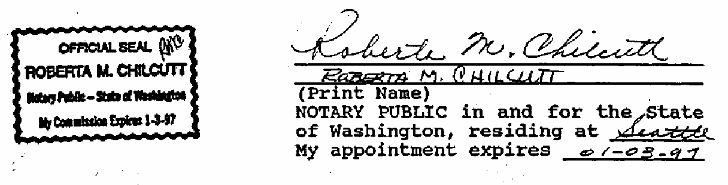
IN WITNESS WHEREOF, I have hereunto set my hand and official seal the day and year first above written.

AFTER RECORDING RETURN TO:
Davis, Wright Tremain ATTN. Warren E. Koons 1800 Bellevue Place 10500 N.E. 8th Street Bellevue, WA 98004-4300

SEVENTH AMENDMENT TO THE DECLARATION AND COVENANTS, CONDITIONS RESTRICTIONS AND EASEMENTS FOR MONTREUX

GLACIER RIDGE PARTNERSHIP (LIMITED PARTNERSHIP), a Washington
limited partnership (the "Declarant"), being the developer of the real property subject to the Declaration and Covenants, Conditions, Restrictions and Easements for Montreux, dated June 14, 1991, and recorded under King County Recording No. 9106210262, as amended by the First Amendment thereto dated December 9, 1992, and recorded under King County Recording No. 9212112069, by the Second Amendment thereto, dated January 29, 1993, and recorded under King County Recording No. 9302021632, by the Third Amendment thereto dated February 19, 1993, and recorded under King County Recording No. 9302241791, by the Fourth Amendment thereto dated December 14, 1993, and recorded under King County Recording No. 9312172692, and by the Fifth Amendment thereto dated April 7, 1994, and recorded under King County Recording No. 9404081834, and by the Sixth Amendment thereto, dated July 8, 1994, and recorded under King County Recording No. 9408091254 (collectively, the "Declaration"), and being the declarant under the Declaration, hereby enters into and executes this Seventh Amendment to the Declaration as of this 14th day of February, 1995.
The Declaration is hereby amended as follows:

RESTATED SECTION 5.2.4 (Minimum House Size)

Section 5.2.4 of the Declaration, relating to Minimum House Size, is amended and restated to read in its entirety as follows:
5.2.4 Minimum House Size. All residences constituting part of a Living Unit shall have a minimum floor area of 2,600 square feet, exclusive of any garage area, unless otherwise approved by the ACC; provided, however, the minimum floor area for residences

constituting part of a Living Unit within Division 2 and on Lots 1-13 of Division 3 shall be 2,200 square feet, exclusive of any garage area, unless otherwise approved by the ACC.

- Except as specifically modified herein, all terms, provisions, and conditions of the Declaration shall remain unmodified and in full force and effect.

Executed as of the date first above written.

DECLARANT: GLACIER RIDGE PARTNERSHIP (LIMITED PARTNERSHIP)
Washington limited partnership
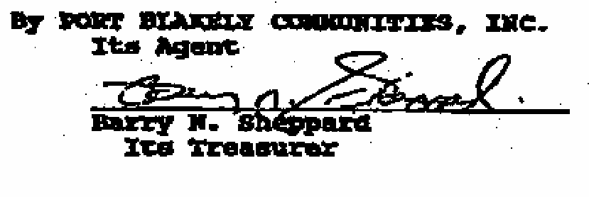

STATE OF WASHINGTON )
) ss.

COUNTY OF KING )
On this 14th day of February, 1995, before me, A Notary Public in and for the State of Washington, personally appeared BARRY H. SHEPPARD, personally known to me (or proved to me on the basis of satisfactory evidence) to be the person who executed this instrument, on oath stated that he was authorized to execute the instrument, and acknowledged it as the Treasurer or Port Blakely Communities, Inc., to be the free and voluntary act and deed of said corporation for the uses and purposes therein mentioned and on oath stated that he was duly elected, qualified and acting as said officer of the corporation; that said corporation is the agent of GLACIER RIDGE PARTNERSHIP (LIMITED PARTNERSHIP), a
Washington limited partnership; that said corporation was authorized to execute the said instrument on behalf of said partnership; and that said instrument was the free and voluntary act and deed of said partnership for the uses and purposes therein mentioned.
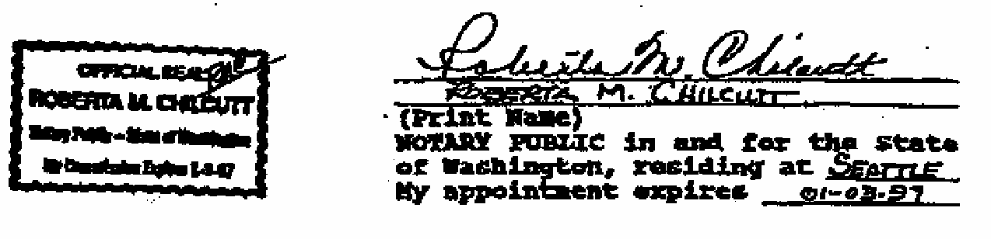
IN WITNESS WHEREOF, I have hereunto set my hand and official seal the day and year first above written.

